Commonwealth Conference on
“Investing on Youth Employment”
London, 9th May 2011,
Key Note Address
By
S Sridhar*

Hon’ble, Chad Blackman, Former Regional Youth Caucus Member, Barbados, Dr. Otuoma Paul Nyongesa, Minister of Youth affairs and Sports, Govt. of Kenya, Ms. Poonam Ahluwalia , President ,Youth Entrepreneurship and sustainability, USA and Enmanuel Dennis, Young entrepreneur and Chief Executive , Green Teams Initiative, Kenya, Mr. Henry Charles, Interim Director, YAD, ladies and gentlemen, Good Morning. At the outset I must complement Commonwealth Secretariat , London to have organized this conference on an important but often overlooked subject. I must also thank them for affording me the privilege of addressing you and participating in this conference.

Youth are a critical part of any nation and deserve the close attention of policy makers. Once again I must appreciate the remarkable initiative of the Commonwealth Secretariat to have picked up youth as one of the themes, and doing such commendable work. The subject of this convention is more relevant today than ever for us from Asia, since there is a consistent enlargement of youth in the demography of Asia. Youth empowerment is increasingly seen as a necessary requirement for the growth of the economy of a country.

My address is divided into six parts:

- Backdrop : Youth and the Global Economy
- Need for Youth Entrepreneurs
- Challenges faced by Youth Entrepreneurs
- Development of Youth Enterprises
- Financing of Youth Enterprises
- Way Forward

Backdrop: Youth and the Global Economy
Global population rose to 6.9 billion in 2010 out of which more than 1.8 billion people constitute what is called as the youth population. Globally, almost 90 per cent of youth are living in developing economies and will continue to be so.
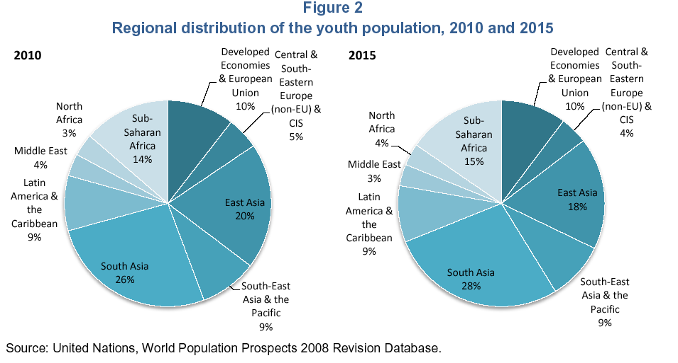

Developing countries are adding over 80 million to the population every year. The potential of youth as growth driver of an economy is well recognized as also in contributing to the inclusiveness of growth. Inclusive growth is the stated objective of all governments.

India's resurgence potential as an economic and a socially responsible power rests on the Indian youth. Statistics like 72 % of India's population is below the age of 40, 47% of is under the age of 20 and 10% of the world population is an Indian under 25 is a common description of Indian demographic profile. It is this population of young people which constitutes, for India, a potential demographic dividend, provided the youth are gainfully utilized.

This predominance of youth in the population is expected to last until 2050. The "BRIC Report" by Goldman Sachs predicts that the economies of Brazil, Russia, India and China would become larger forces over the next 50 years and mentions that India's economy could be larger than Japan's by 2032, that the combined GDP of the BRIC countries would cross that of the G6 by 2039 and that India could perhaps exhibit the fastest growth in the next 30 years.

This high growth over the next 3 decades will prove to be the biggest opportunity for India, and especially its youth, whose potential needs to be harnessed rightfully and beyond boundaries. India's youth have a very unique advantage, a combination of mobility, language, education, a thirst for knowledge and a technology-savvy nature, qualities that will drive the nation's growth in the coming years. What the youth can expect in the years to come will depend on how well they understand and leverage their rights and how willingly and efficiently they are able to shoulder their responsibilities. Fortunately, the current knowledge base of the society, as also the experiences of the past, is broad enough to help the present generation overcome the challenges with confidence and zeal.

Need for Youth Entrepreneurs

Entrepreneurship at macro and micro level is essential in creating economic resurgence in today's global economic scenario. More importantly the Indian entrepreneurial model is key to an inclusive approach to wealth creation that is necessary to address the income inequalities in the world today. Enterprise development has been a key ingredient of economic growth the world over. Enterprise creation spurs trade, empowerment, prosperity leading to wealth creation. Youth entrepreneurs which are generally small or micro enterprises have a special role in enterprise development perhaps disproportionate to their number and value of investment made for.

First, an economy’s prosperity is highly dependent on a dynamic entrepreneurship sector. This is true across all stages of development. Yet the nature of this activity can vary in character and impact. Necessity- driven entrepreneurship, particularly in less developed regions or those experiencing job losses, can help an economy benefit from self-employment
initiatives when there are fewer work options available. More developed economies, on the other hand, can leverage their wealth and innovation capacity, yet they also offer more employment options to attract those that might otherwise become entrepreneurs. In order to maintain their entrepreneurial dynamism, they need to instill more opportunity based motives.

Second, an economy’s entrepreneurial capacity requires individuals with the ability and motivation to start businesses, and requires positive societal perceptions about entrepreneurship. Entrepreneurship should include participation from all groups in society, including women, a range of age groups and education levels and disadvantaged populations.
Finally, high-growth entrepreneurship is a key contributor to new employment in an economy, and national competitiveness depends on innovative and cross-border entrepreneurial ventures.

As an economy develops, productivity increases and, consequently, so does per capita income. This is often accompanied by the migration of labor across different economic sectors. For example, labor may move from agricultural and extractive sectors to manufacturing, and then eventually to services. In their early stages of development, economies typically have a higher proportion of necessity-driven activities. Here, the demand for jobs in high productivity sectors outpaces supply. As a result, many people must create their own source of income.

With further development comes the growth of productive sectors. This increases employment capacity but leads to gradual declines in the level of necessity-driven entrepreneurship. At the same time, improvements in wealth and infrastructure stimulate opportunity-based businesses, shifting the nature of entrepreneurship activity. These ventures are more likely associated with greater aspirations for growth, innovation and internationalization. They rely, however, on the economic and financial institutions created during the developing phases. To the extent these institutions are able to accommodate and support opportunity-seeking entrepreneurship activity, innovative entrepreneurial firms may
emerge as significant drivers of economic growth and wealth creation.

Why support Youth Enterprises ?
First, Youth enterprises contain the germ of large enterprises. Many of the leaders, corporate empires had started off small by the founders in their relative youth. Thus nurturing youth enterprises ensures that the pipeline of business enterprises and the momentum of economic growth is sustained.

Second, Youth enterprises tend to incorporate into their operations, the local dimensions of entrepreneurship much more than large corporate enterprises. These include use of local resources, local talent, grass root innovations. Thus youth enterprises contribute to inclusive growth.

Third, Youth enterprises tend to be more innovative, bring new ideas, respond more swiftly to demands made on them by buyers, employees, other stakeholders. Thus youth enterprises have higher potential to be part of an upward spiral of quality, delivery and innovation.

Fourth, Youth enterprises represent constructive and productive way of youth engagement. The energy, vitality, talent of the youth can easily be misdirected elsewhere with adverse consequences not only for the concerned but also for the society. Unemployed youth are estimated to be 81 million in the world at the end of 2009 and the number is growing. This represents only those who have formally registered; the number of informal (unregistered) unemployed should be higher by many multiple. The number of under employed can be expected to be even higher.

Challenges faced by Youth Entrepreneurs
The issues identified include affordable institutional access to finance, need for a collaborative platform that integrates key stakeholders and services the needs of entrepreneurs, working to build and celebrate an entrepreneurial culture, creating a supportive tax and regulatory ecosystem that promotes business growth and focus on developing a comprehensive system of education and skills training to encourage new ventures.
To elaborate the constraints :
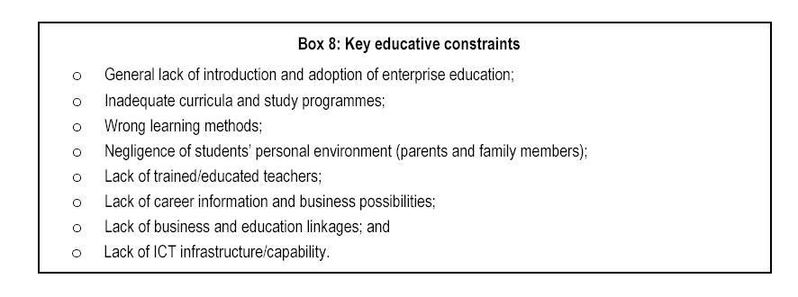
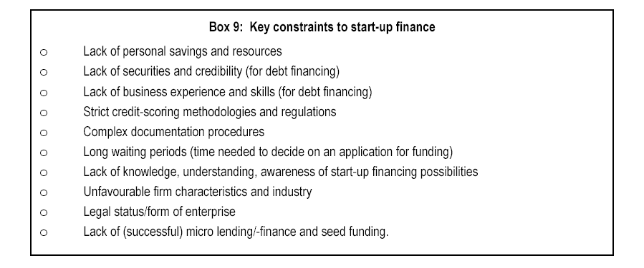

Development of Youth Enterprises

Employment opportunities for the youth are either in jobs i.e. or in own enterprises i.e. self employed. Given the difficulties faced by an entrepreneur, that too youth, it is no surprise that a vast majority of the youth settle for some job or the other. On the other hand, self employment or entrepreneurship can help create sustainable growth and also reduce the competition for scarce jobs. In this event of a recession, widespread of downturn, losses have led to self-employment albeit forced in many cases. This is not entrepreneurship. An entrepreneurship is not one between two jobs. An entrepreneur is a ‘job creator’, not a ‘job seeker’ and that is the way to go.

Based on my experience in the field, I am of the view that there needs to be an appropriate and favourable eco-system for development of Youth enterprises. This eco-system will need to have key components.

First and foremost, is an attitude and culture both in the young people as well as in the society at large which is conducive to entrepreneurs. For instance, failures should not be looked down as long as the effort was genuine and serious.

Second, the availability of niche capital and institutional finance is critical. In developing countries, even the so called venture capital is looking at early stage investments.

Third, entrepreneurship needs to be looked at as a career option and as a last resort. To this end, youth must be sensitized right from high school onwards; achievements of young entrepreneurs must be publicized widely and acknowledged in educational institutes. Higher education institutes and universities would need to offer courses and placements with successful entrepreneurs acting as mentors.

Fourth, creation of a knowledge infrastructure as public private partnership ventures with lead taken by industry associations which can be tapped by budding entrepreneurs on an ongoing basis. This knowledge infrastructure will cover marketing, technology, soft skills, personnel issues, contracting etc. Most important of all is skill development of the entrepreneur who necessarily has to be a doer. He cannot be a delegater as there is no one to delegate to.

In India we have created a PPP vehicle by the name National Skill Development Corporation (see box-1 below) that seeks to skill 500 mn youth before 2022. In other words this ecosystem is a multi stake holder partnership to nurture youth entrepreneur and enterprises.

Box-1
National Skill Development Corporation (NSDC)
NSDC has been set up in 2009 as a Public Private Partnership under the aegis of Ministry of Finance, Govt of India. Objectives are :
- Upgrade skills to international standards through significant industry involvement and develop necessary frameworks for standards, curriculum and quality assurance
- Enhance, support and coordinate private sector initiatives for skill development through appropriate Public-Private Partnership (PPP) models; strive for significant operational and financial involvement from the private sector
- Focus on underprivileged sections of society and backward regions of the country thereby enabling a move out of poverty; similarly, focus significantly on the unorganized or informal sector workforce.
- Play the role of a "market-maker" by bringing financing or viability gap funding, particularly in sectors where market mechanisms are ineffective or missing
- Prioritize initiatives that can have a multiplier or catalytic effect as opposed to one-off impact

Financing of Youth Enterprises

A youth enterprise, like any other enterprise needs finance in the form of equity and debt. Table 1 gives the various forms of equity and debt required by any startup enterprise. Affordable finance is required for enterprise creation and growth.

Table-1

Financing for a start up

Equity Debt (Term Loans, mezzanine,
- Angel Investors working capital, Factoring,
- Venture Capital - Banks
- Private Equity (not preferred) - Co operative Institutions
- Buyer Equity - Private Sources (Cost intensive)
- Non Banking Finance Company
- Development Finance
Institutions

The distinct financing needs of a youth enterprise are I) risk capital for startup operations particularly proof of concept and prototyping; this is usually available from angel venture capitalists, II) Cashflow not asset based, non-collateral based financing. Hence buyer backed supply chain financing or factoring i.e. non-recourse invoice discounting where the financing is extended on the credit standings of the buyer rather than the youth enterprise, are forms of financing that need to be encouraged, III) Supporting financing infrastructure that keeps transaction cost low such as electronic payments, web based B to C portals, contract manufacturing.

Institutional finance for youth enterprises needs to have a framework with the following key factors :

- Adequate Liquidity - Availability of debt in adequate quantum will ensure that no liquidity crunch is experienced which can lead to a solvency crisis.
- Cost of financing should be reasonable – A youth startup will not be in a position to bear high interest cost. At the same time credit risk are compelling lenders to charge high rates of interest as the credit ratings of the entrepreneur is usually low. A viability gap funding in initial years by Government or Government designated agencies may be considered.
- Government policies, regulatory policies should be positively discriminated towards youth enterprises for instance such financing can be made part of affirmative action such as priority sector policies in India.
- Suitable risk mitigants such as a credit Guarantee scheme to facilitate easy flow of collateral free lending by mainstream lending institutions need to be put in place and made functionally easy to use. At the same time, moral hazard issues need to be kept in view to ensure a careful balance.

Central Bank of India of which I am the CEO is an example of a mainstream bank that has launched an innovative youth enterprise financing programme in collaboration with Comsec. It is aimed at youth micro entrepreneurs in backward areas of the country. The distinguishing characteristics of the programme is that it is holistic financing combining group finance for skill development (from Comsec), concessional loans for investment in the in the micro entrepreneur and working capital ( Central Bank) and grant finance for developing marketing linkages (from Comsec). Thus the programme seeks to provide end to end financing. Box-2 gives some details.

Box-2

CENTRAL BANK OF INDIA- COMMONWEALTH JOINT
YOUTH ENTERPRISE PROGRAMME

Objective :

Youth Enterprise Financing Programme aims at providing end to end solution including finance for micro enterprises set up by youth in backward districts in the country. The range of activities covered include skill development, investment in the micro enterprise, setting up effective market linkages. Thus, it is sought to be ensured that the financing is provided along with assistance for backward and forward linkages.

The Concept :
The concept is replicable by having strategic partnership/collaboration among National Development organisations, banking institutions, corporate sectors and NGOs for youth enterprise development. It has multiplying effect in employment generation as every enterprise will create in turn several employment opportunities. This would help create opportunities for young people to drive socio-economic development that might help reduce costs associated with tackling social problems such as substance abuse, crime and violence.

The programme involves :
- Selection of youth entrepreneurs
- Capacity building of the identified entrepreneurs by Bank and NGO Partners.
- Local coordination and mentorship of entrepreneurs
- Providing bank finance
- Monitoring and project oversight (jointly)
- Evaluation (jointly)

Central Bank of India is a leading public sector bank in India with 3728 branches (3rd largest in India), 35000 plus staff and annual turnover of over US$ 65 bn. It is now in the Centenary year and has a customer base of about 30 mn.

Financial Inclusion:

Indian banks have embarked on a remarkable nation wide programme of Financial Inclusion in terms of which, every household in this country will be financially included over the next 5 years. This amounts to new bank accounts of 225 million Financial Inclusion is sought to be achieved through use of Information & Communications Technology (ICT), arguably the largest of its kind in the world in terms of its scope and volume. The substantive financially included, in about five years’ time, will no doubt be a game change for governance and business.

Under the Financial Inclusion initiative, the customers are offered a saving account, micro-credit, micro-remittance and a third party product like micro-insurance. To reach the unbanked areas, the banks are actively using Biometric Smart Cards and Hand Held Terminals to facilitate banking transaction in a transparent and low cost manner. The bank’s use intermediaries known as Business Correspondents (BCs) who are individuals or corporate entities, both for profit and not for profit. The BCs provide the last mile connectivity through visits to the households. Banks are also leveraging various other ICT enabled delivery channels such as mobile phones, e-Kiosk , Mobile Banking Unit etc.

Banks have drawn three year roadmaps i.e Financial Inclusion Plan to provide banking services to the urban and rural poor, through a combination of brick and mortar branches and ICT based models of delivery using BCs. Our Bank envisages covering 40,000 villages in 5 years which include 3741 villages having population more than 2000, the balance with population below 2000, allotted to bank. In Central Bank of India we have covered a total of 5,696 villages including 1776 allotted villages issued 1.32 million cards by appointing 2480 BCs.

The recent initiative of GoI in setting up of Unique Identification Authority of India (UIDAI) which will issue Unique Identification Number known as “Aadhaar” to all its residents is in full swing. Aadhaar is being implemented b banks who see the synergy between Aadhaar and banks account. In addition to this UIDAI is also setting up the micro payment platform known as Aadhaar enabled payment system i.e AEPS which the transaction will be authenticated online based on biometrics. This micro payment platform will facilitate interoperability across each BC and Bank.

WAY FORWARD

Entrepreneurship in general and youth entrepreneurship in particular is a complex and sensitive phenomenon. India is acknowledged to possess entrepreneurship quality and as per the Global Entrepreneurship monitor 15 out of 100 Indians aspire to be entrepreneur. Even so, based on my experience as an active observer and financier, entrepreneurs face more than normal share of impediments and barriers. In my view, financing is not that much of an issue as that development of youth enterprises and their nurturing and mentoring. I have outlined a possible framework. The evolution of the appropriate ecosystem is the key success factor. In different countries there are different missing links in the ecosystem. They need to be identified and institutional mechanism as per the national ethos be created or strengthened, through which the necessary knowledge and social capital are also channelised. The mainstreaming of youth enterprises development is called for. The institutional mechanism must possess the qualities of replicability, scalability, traceability and accountability. Cross sector and sometimes perhaps, cross border collaborative partnerships need to be forged and used for the benefit of the local entrepreneurs.

To conclude, the vision of any developing economy is to provide employment opportunities to the youth as also space for entrepreneurship development and enterprise creation. This will enable them to access opportunities provided by economic growth and make that growth more inclusive and shared. I believe that any nation that looks at youth empowerment as a key area for its economic growth and provides a platform for garnering the energy of the youth into a successful trajectory for employment would necessarily have to invest policy, intellectual, social, financial capital in youth enterprises.

Thank You…..

